AUTUMN NEWSLETTER

Heritage Crime Awareness & Anti-Social Behaviour Week.
During Heritage Crime Awareness Week, Gwent's Rural Crime Team visited several heritage sites across the force area, engaging with local communities and raising awareness of the importance of protecting our historic landmarks.

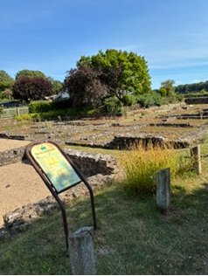


Highlights included a visit to Caerleon Amphitheatre, where officers worked alongside CADW volunteers to speak with visitors about the site's history and how everyone can help safeguard local heritage.
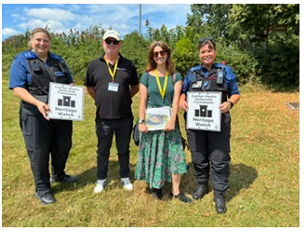

PCSO247 Kim, Rob, Serena and PCSO139 Ruth.

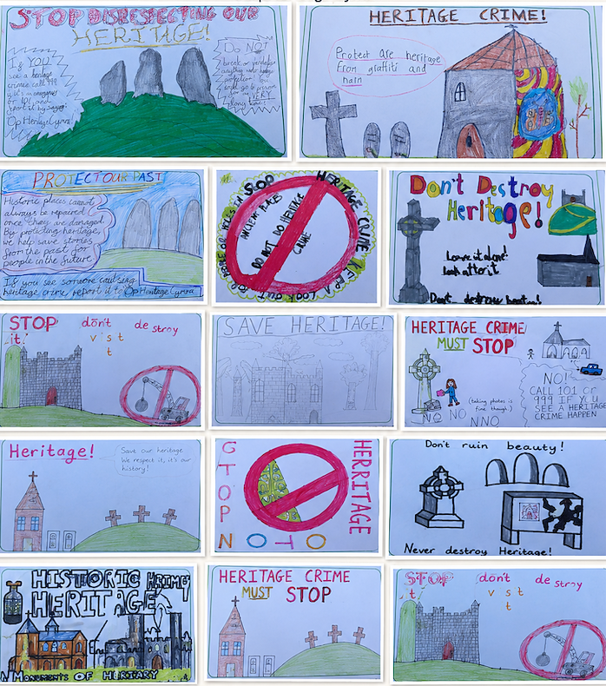
The team along with Kate Churchill (Police Volunteer Archaeologist) visited Trellech Primary School, where pupils learned about heritage crime and created their own awareness posters, demonstrating great enthusiasm for protecting local history.

The week concluded at the Monmouth Medieval Festival, attended by more than 3,000 visitors. Officers engaged with the public throughout the day, promoting heritage crime awareness while celebrating the area's rich history alongside a variety of medieval attractions and activities.
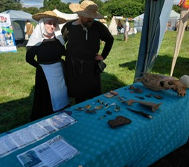
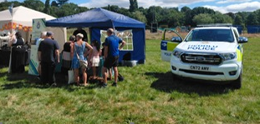
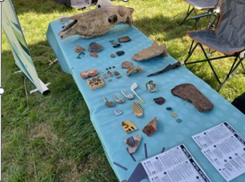

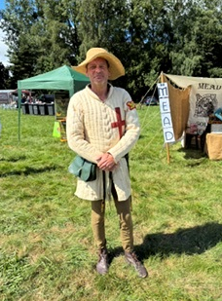
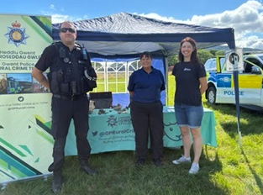
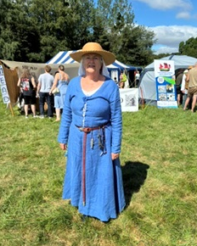
The successful week highlighted the importance of partnership working, education, and community engagement in preserving Gwent's heritage for future generations.

Wales Capabilities Day
During July, members of the Rural Crime Team attended the All-Wales Capabilities Day at Builth Wells. The event brought together a wide range of organisations and agencies from across Wales with the shared aim of increasing awareness of specialist capabilities and strengthening working relationships. By building these valuable partnerships, agencies are better prepared to respond effectively when incidents arise and ensure the best possible support for communities across Wales.
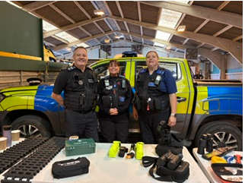
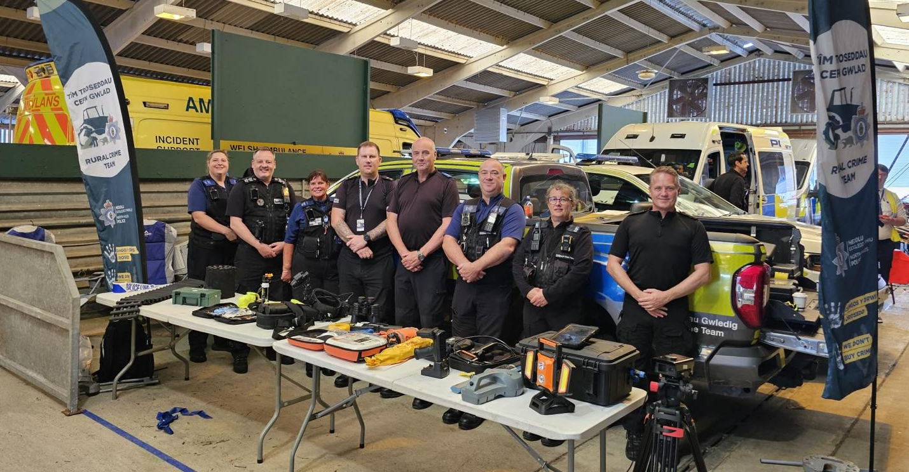
The Rural Crime Team is also pleased to announce the launch of the Rural Watch Scheme. This simple but highly effective initiative helps keep farming and rural communities informed about local incidents, crime prevention advice and important updates affecting the countryside.
To help spread the word, officers have been visiting local livestock markets and speaking directly with farmers about the benefits of joining the scheme. The response has been extremely positive, with many members of the farming community signing up to stay connected and informed. Anyone interested in joining the Rural Watch Scheme can register their interest by contacting Ruralcrimeteam@gwent.police.uk.
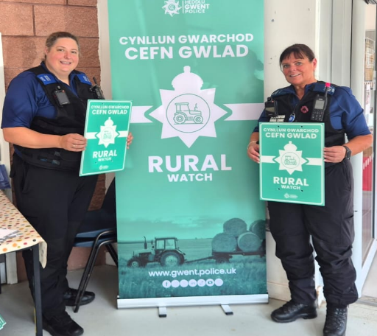

Supporting Farming Community Wellbeing
Looking after the wellbeing of our rural communities is just as important as tackling crime. With this in mind, members of the Rural Crime Team recently attended a RABI NVQ Level 3 course focused on mental health awareness within the farming community.
The training provided officers with a greater understanding of the challenges that can affect mental health in rural settings, how to recognise the signs that someone may be struggling, and how to start supportive conversations. The course also highlighted the range of organisations and services available to provide help and guidance when it is needed most. By developing these skills, the team is better equipped to support members of the farming community and ensure that those in need are directed towards appropriate assistance.

Royal Welsh Show
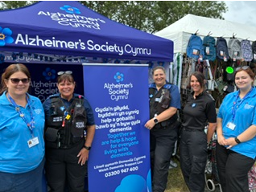
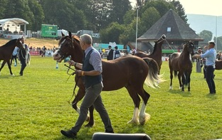
The Rural Crime Team was proud to attend this year's Royal Welsh Show, one of the largest and most celebrated agricultural events in Europe, providing a fantastic opportunity to engage with the farming community, rural businesses, and visitors from across Wales.

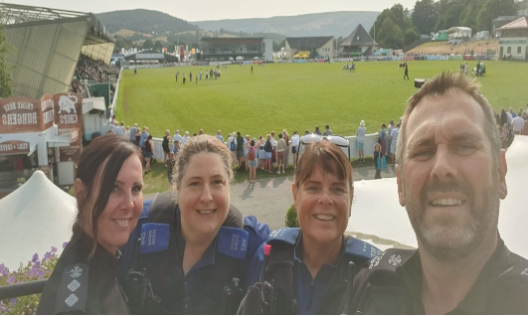
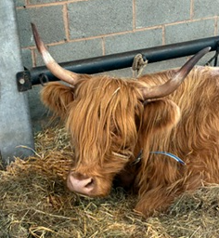

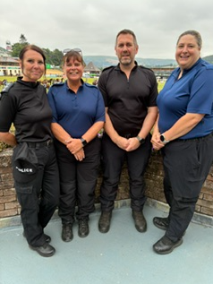
Throughout the week, we spent time speaking with members of the public, discussing the work carried out by the team to tackle rural crime and support those who live and work in our countryside. The event provided an excellent platform to strengthen relationships with farmers, agricultural organisations, and partner agencies, while sharing crime prevention advice and highlighting the importance of reporting incidents in rural areas.

Operation Seabird Cymru Returns to Protect Wales’s Precious Coastal Wildlife
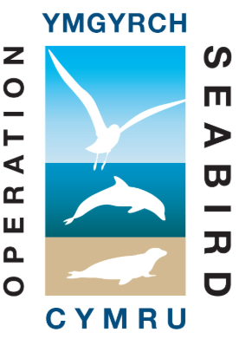
Operation Seabird Cymru is back for another year, helping to protect the wildlife that calls the Welsh coastline home.
Running throughout the summer, the campaign reminds visitors to enjoy Wales's beautiful beaches, cliffs and coastal paths responsibly by following one simple message:
"Observe, Don't Disturb."
Keeping your distance from wildlife, keeping dogs under control, avoiding nesting areas, and not approaching or feeding wild animals can help protect vulnerable species such as seabirds, seals and dolphins.
Even well-meaning interactions can cause distress, leading animals to abandon nests, become separated from their young, or leave important feeding and resting areas.
If you are concerned about an animal's welfare, do not approach it. Keep a safe distance and contact the RSPCA helpline on 0300 1234 999 for advice.
Together, we can help protect Wales's spectacular coastal wildlife this summer. Observe, Don't Disturb.

Rural Crime Team Out and About Across Gwent
The Rural Crime Team has been busy attending a range of community engagement events across Gwent and alongside colleagues from Dyfed-Powys Police, strengthening partnerships and connecting with local communities.
From the Cwmbran Big Event and Monmouthshire Livestock Market, Royal Welsh Show to the Bedwellty Show, Monmouth Show, and Usk Show, the team has welcomed hundreds of visitors to their stands throughout the year.
These events provide an invaluable opportunity to meet residents, farmers, landowners and businesses face-to-face, discuss local concerns, and share practical crime prevention advice. They also allow the team to raise awareness of rural crime issues, showcase specialist equipment and tactics, and highlight the ongoing work being undertaken to keep our communities safe.
Whether in our villages or countryside, the Rural Crime Team remains committed to supporting both rural and urban communities across Gwent, building trust, and working together to prevent crime and protect what matters most to local people.


